Learning Module - Poverty and Education
PRE-LEARNING (recommended): This learning module builds from skills learned after completing the Introduction to Vital Signs Module.
In this module, you will be examining data from the Vital Signs indicators produced annually by the Baltimore Neighborhood Indicators Alliance (BNIA) at the University of Baltimore to understand the links between poverty and education. You will then answer the six questions in the Assignment section.
What You’ll Need to Complete This Learning Module
- Access to the Internet (either desktop, laptop or phone)
- the latest Chrome or Safari browser
- a place to write down your thoughts/answers
Topic Background Information
The relationship between poverty, neighborhoods, and educational achievement has long been understood by researchers, homebuyers and elected officials. Perhaps the most compelling study is the book The Long Shadow^{[1]}, which examines these issues right here in Baltimore. In the work, the authors state that, “The overlapping spheres of influence imagery implies that family socioeconomic level, neighborhood, and school are vehicles, at least potentially, for the transmission of social advantage and disadvantage across generations” (2014:74).
In this module we will be examining Vital Signs data to assess the “overlapping spheres” between poverty, neighborhoods, and educational achievement in Baltimore City.
Step 1—Understanding Indicators
There are more than 100 indicators in Vital Signs. This website lists all the indicators and their definitions www.bniajfi.org/indicators/all.
Here are some of the indicators that are most related to Poverty and Education.
- Percent of Family Households Living Below the Poverty Line (2019)
- Unemployment Rate (2019)
- Percentage of 5th Grade Students who Met or Exceeded PARCC Reading (2017)
- High School Completion Rate (2017)
- Percent Population (25 years and over) with a Bachelor’s Degree or Above (2019)
For each indicator consider the following questions:
- What concept does this indicator attempt to quantify?
- What is the source of the data and how does this affect the measurement?
- What are the strengths and limitations of this indicator?

Here are the descriptions of each of these indicators.
Indicators | Definitions | Source
Percent of Family Households Living Below the Poverty Line | This indicator measures the percentage of households whose income fell below the poverty threshold out of all households in an area. Federal and state governments use such estimates to allocate funds to local communities. Local communities use these estimates to identify the number of individuals or families eligible for various programs. | American Community Survey (U.S. Census)
Unemployment Rate | The percent of persons between the ages of 16 and 64 that are in the labor force (and are looking for work) but are not currently working. | American Community Survey (U.S. Census)
Percentage of 5th Grade Students who Met or Exceeded PARCC Reading | The percentage of students who met or exceeded PARCC exams in reading and mathematics in 3rd, 5th, and 8th grades. Partnership for Assessment of Readiness for College and Careers (PARCC) scores measure the number of students scoring in one of three classifications out of all students enrolled in that grade. Students can either be rated as exceeded, met, approached, partially met, or did not meet expectations of a subject. This indicator includes only those students who have tested as exceeded or met expectations. | Baltimore City Public Schools
High School Completion Rate | The percentage of 12th graders in a school year that successfully completed high school out of all 12th graders within an area. Completers are identified as completing their program of study at the high school level and satisfying the graduation requirements for a Maryland High School Diploma or the requirements for a Maryland Certificate of Program Completion. | Baltimore City Public Schools
Percent Population (25 years and over) with a Bachelor’s Degree or Above | The percentage of persons that have completed, graduated, or received a Bachelor's or an advanced degree. This is an indicator used to measure the portion of the population having an advanced level of skills needed for the workplace. Persons under the age of 25 are not included in this analysis since many of these persons are still attending various levels of schooling. | American Community Survey (U.S. Census)

Step 2—Visualizing Indicators
On the Vital Signs page of the BNIA website, www.bniajfi.org, click on “Vital Signs by Indicators” to do a keyword search for one or more of the above indicators.
Use the interactive visualizations to identify the Community Statistical Area (CSA) that has the following:
- CSA with the Highest Level
For example, if you search for “Percent of Family Households Living Below the Poverty Line” click on the “Indicator Charts” tab and then the “Max-to-Min" organizer (See circled area in the figure below). The CSA that is listed at the top will be the CSA with the Highest Poverty Level.
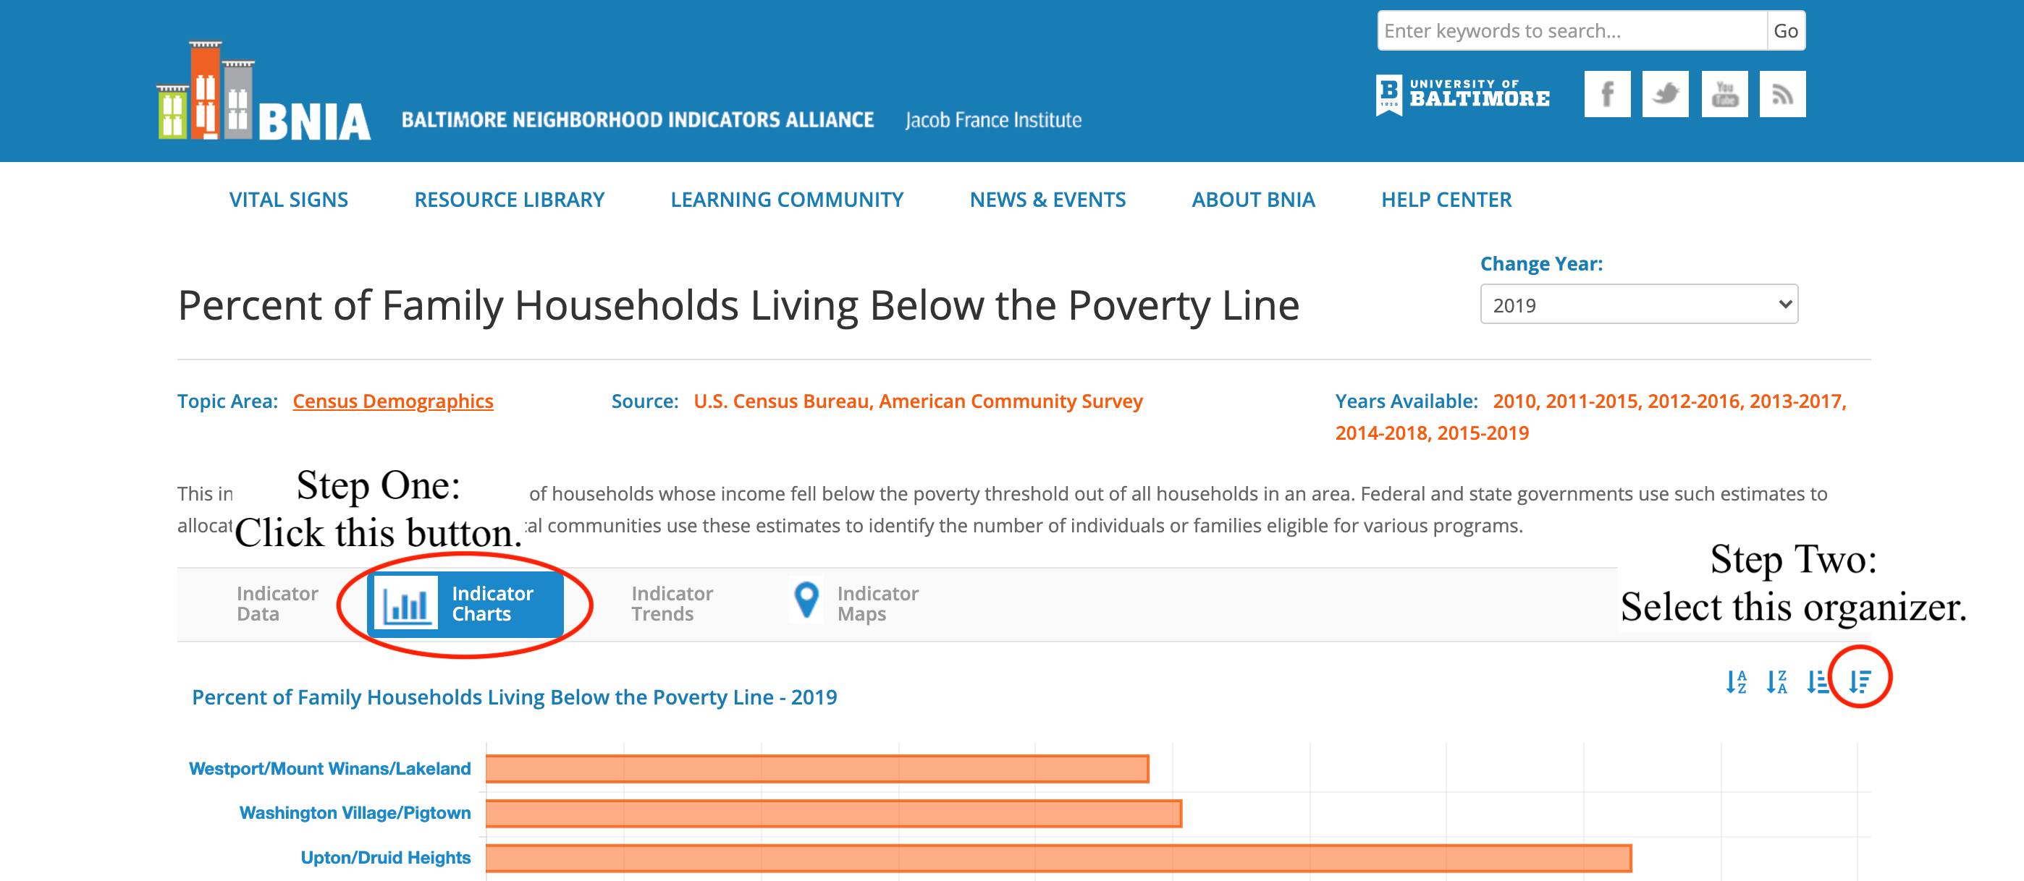
- CSA with the Lowest Level
Staying on the same page, select the “Min-to-Max" organizer. The CSA that is listed at the top will be the CSA with the Lowest Poverty Level.
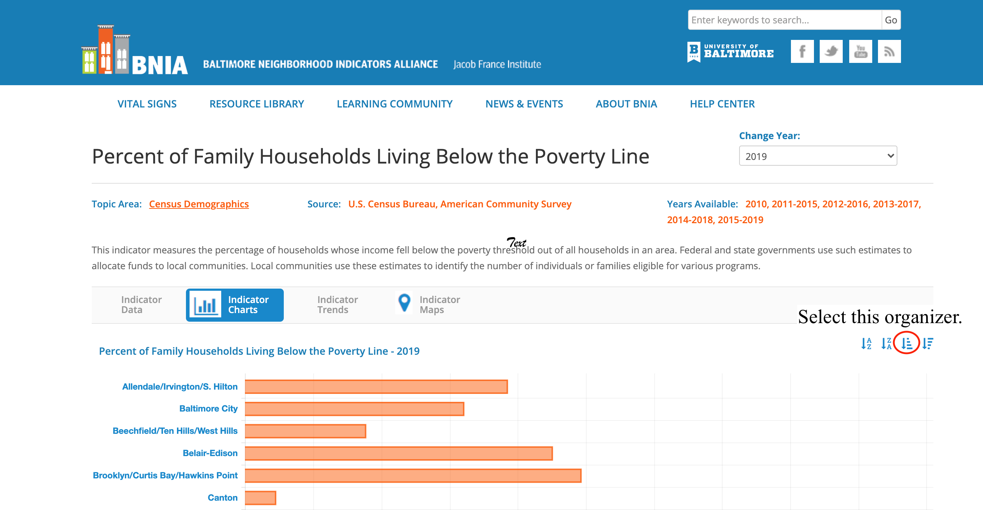
- Finding Trends
The next step is to select the “Indicator Trends” tab. Next select the CSA that you determined to have the highest poverty and lowest poverty. Also select Baltimore City. Below is what you should be seeing.
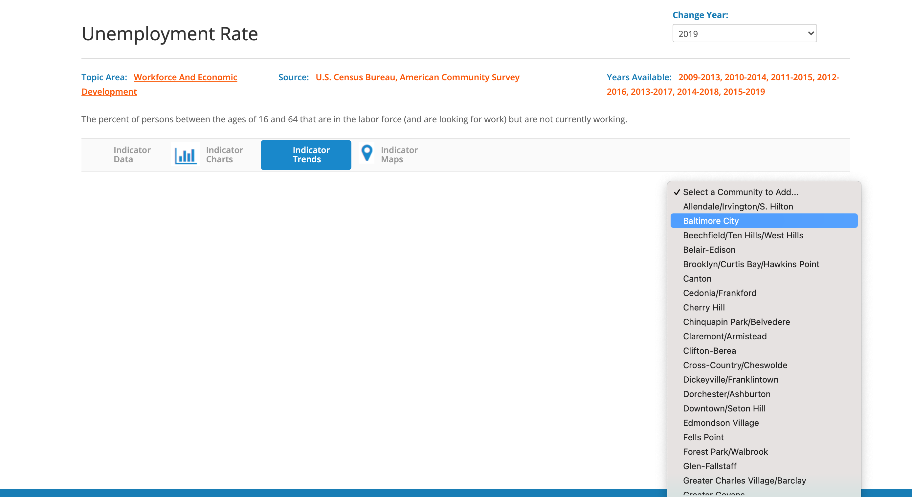
After you have made your selections, a chart will show up (these CSAs are not necessarily the correct answers for the highest and lowest poverty levels!). The graph shows a comparison of the indicators among those three CSAs.
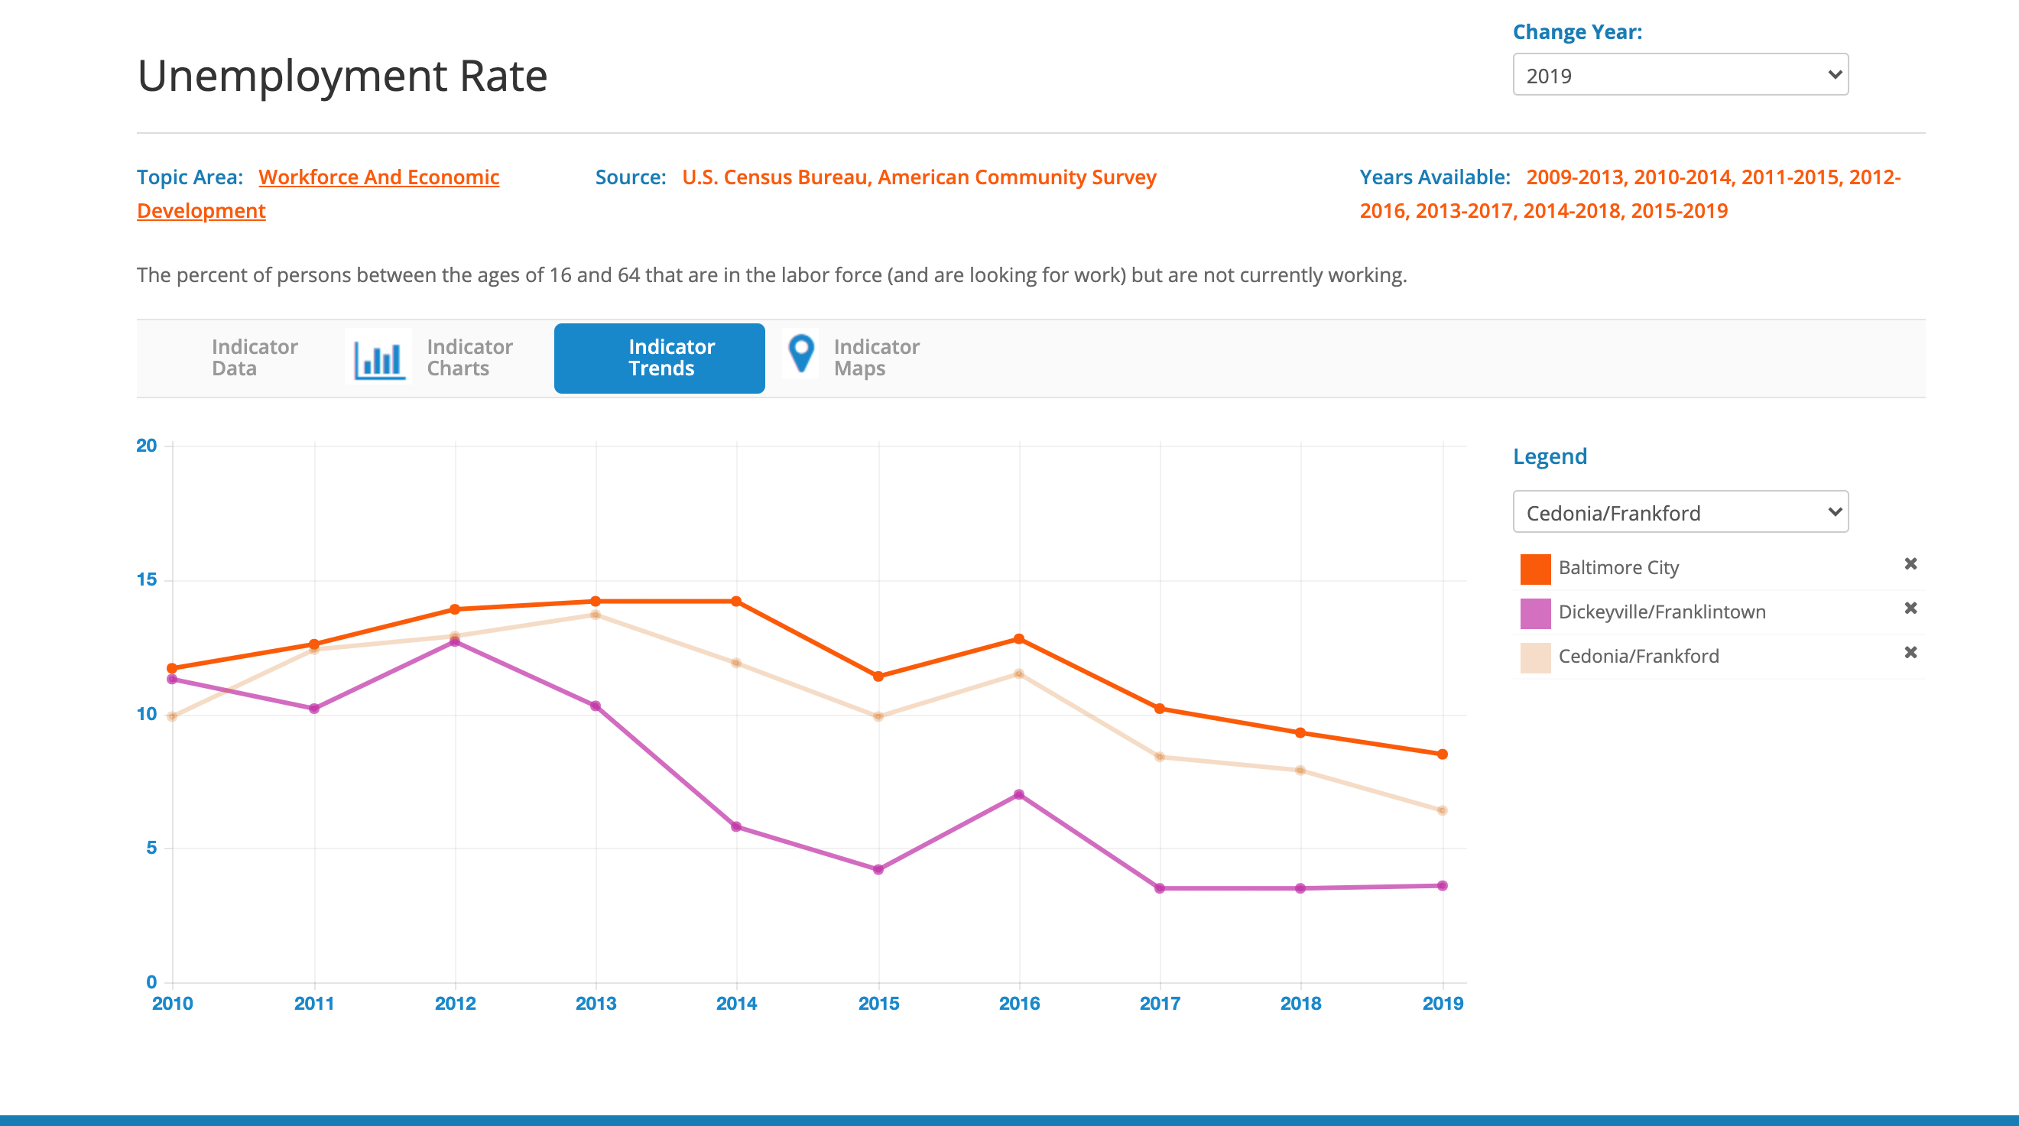

Step 3—Assignment
1) How do the communities with high poverty levels and rank among communities in terms of 5th grade reading abilities? What are some of the reasons that might explain this relationship?
2) What is the relationship between communities with highest 5th grade reading abilities and college educated people in these CSAs? What are some of the reasons that might explain this relationship?
3) What is the relationship between communities with unemployment and high school education? What are some of the reasons that might explain this relationship?
4) What is the relationship between communities with high poverty levels and college education? Also consider 5th grade reading levels with poverty and college education and provide some social factors that might explain these relationships.
5) Now, play around with the chart a little and select some other CSAs that have high or low poverty. Do the relationships you discussed above still hold true?
6) After looking at this data and answering these questions, discuss the general relationship between poverty and education. What are the challenges that a child or teenager from a CSA with high poverty rates might face in succeeding in their education?

^{[1]} Alexander, Karl, Doris Entwhistle, and Linda Olson
2014 The Long Shadow: Family Background, Disadvantaged Urban Youth, and the Transition to Adulthood.
New York, NY: Russell Sage Foundation.

