SOCIAL DETERMINANTS OF HEALTH
Adapted from Unnatural Causes lesson plans.^{[i]}
PRE-LEARNING (recommended): This Learning module builds from skills learned after completing the Vital Signs Module.
In this module we will be examining Vital Signs data to understand the effect of social determinants on health outcomes across neighborhoods in Baltimore City. You will then answer the seven questions in the Assignment section.
Introduction
The Centers for Disease Control and Prevention define social determinants of health as:
“The complex, integrated, and overlapping social structures and economic systems that are responsible for most health inequities. These social structures and economic systems include the social environment, physical environment, health services, and structural and societal factors. Social determinants of health are shaped by the distribution of money, power, and resources throughout local communities, nations, and the world”.^{[ii]}

Below are some major dimensions of social determinants of health:
• Physical and Built Environment- Presence and quality of features of space and geography that determine access to health benefits or exposure to health risks.^{[iii]} (Ex. quality of housing stock, access to supermarkets, walkability, traffic, pollution)
• Social Environment- The presence or absence of interpersonal relationships, groups, and networks that provide support, solidarity, partnership, and sense of belonging for residents.^{[iv]} (Ex. crime, degree of racial integration or segregation, views on local government, community engagement)
• Economic Environment- The presence or absence of commercial investment and businesses that provide residents with adequate income (employment, tax base) and health-promoting goods and services (produce, banking).^{[v]}
• Service Environment- The presence or absence of adequate schools, police and fire protection, water and sewer systems, healthcare facilities, mass transit, and other services that allow residents to live healthy, safe, productive lives.^{[vi]}

Given the strong influence of these determinants on health, differences in these determinants can result in marked health disparities between communities. Let’s examine how social determinants of health play out at the neighborhood level in Baltimore City.

Step 1: Below is a list of Vital Signs indicators that could measure each of the dimensions identified above. Choose 3-4 indicators for each dimension. For each indicator, briefly discuss what aspect of the dimension you are hoping to measure and the strengths and weaknesses of using these indicators as measurements.
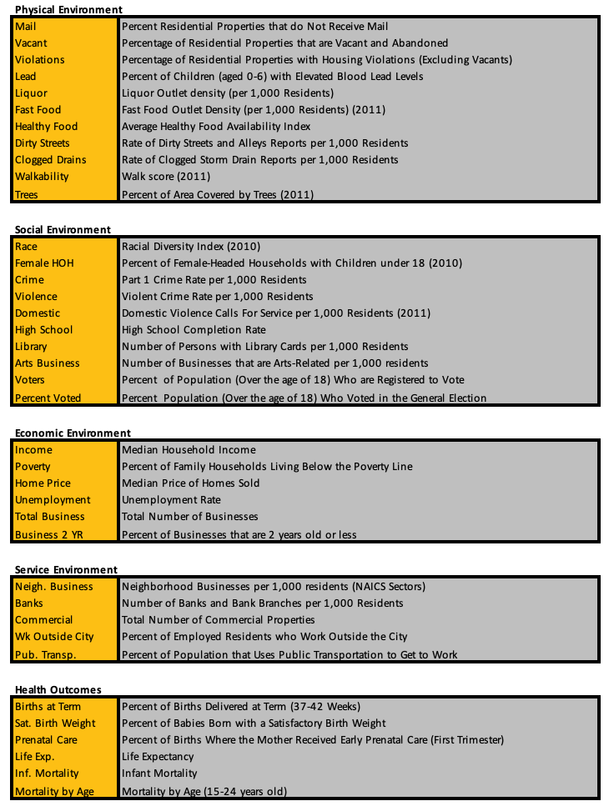
Step 2: The next step is to look at “Vital Signs By Indicator.” From here you will enter the indicators listed above. Once the indicator has been selected you will select the “Indicator Trends” tab. Next select three different CSAs that you would like to research. Also select Baltimore City. Below is what you should be seeing.
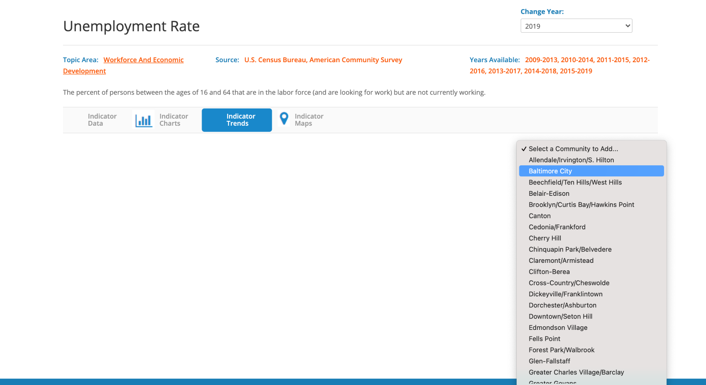
After you have made your selections, a chart will show up comparing the indicator data among the CSAs that you chose (these CSAs and indicators only serve as an example).
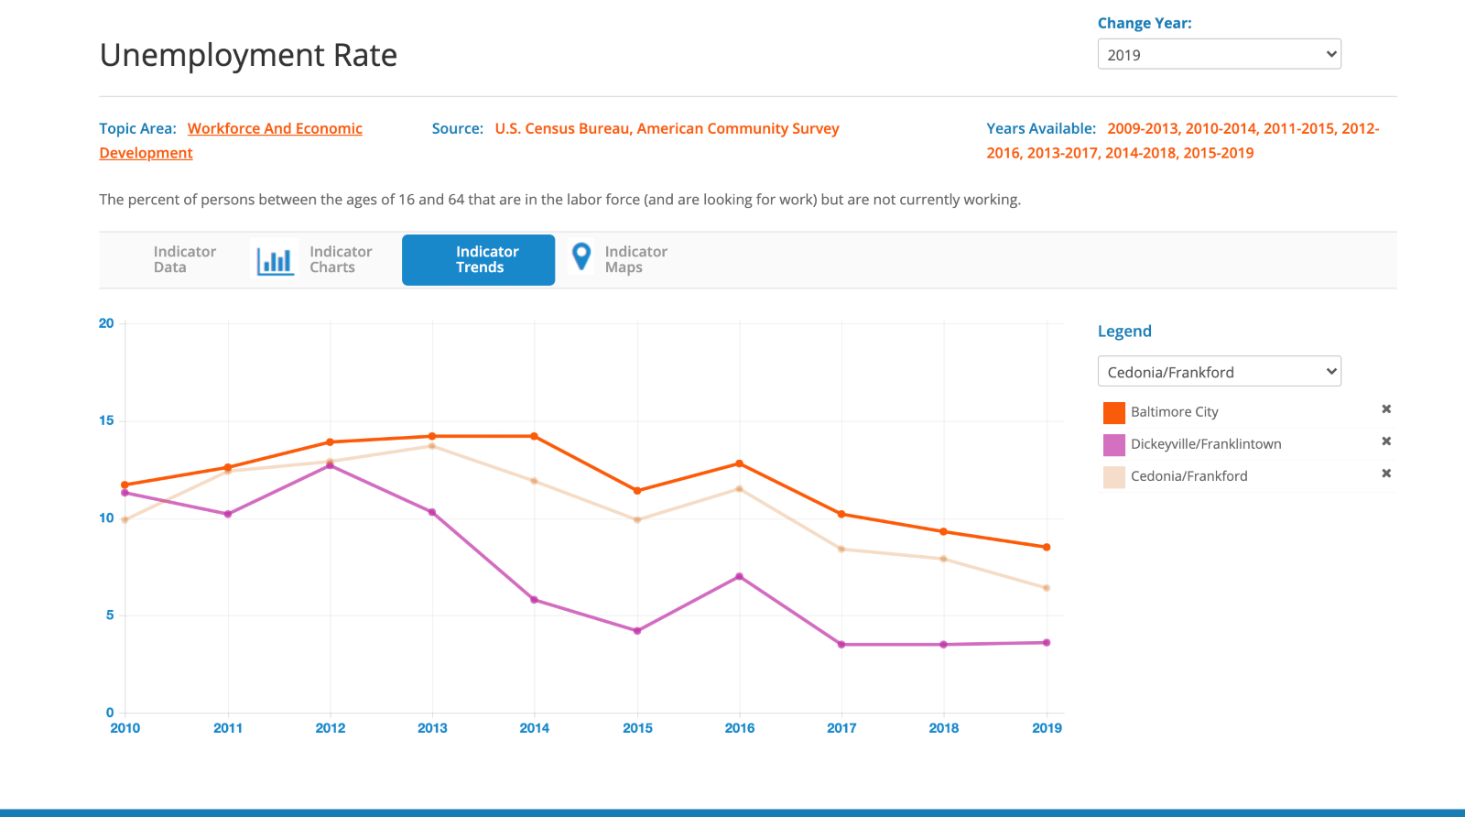

Step 4: Compare each of the indicators for your CSA to the average given for Baltimore City. For each of these indicators for your CSA, discuss whether having a higher or lower number than Baltimore would positively or negatively affect health outcomes.

Assignment:
1) How do the social determinants of health indicators relate to the health outcomes you identified?
2) Did you predict the health outcomes given the table of social determinants of health you identified?
3) Would you say this is a healthy neighborhood?
4) What seem to be some of the biggest problems residents face?
5) What are some of the best assets they have?
6) How accurate or comprehensive do you think your data are?
7) How can this information be used to inform policies and programs to improve health in this community?

Another source of health outcomes is the Baltimore City Health Department Neighborhood Health Profiles
^{[i]} Unnatural Causes Website. “Place Matters: Exploring Our Neighborhoods.” Lesson Plan developed by Manon Parry for California Newsreel. Accessed August 1, 2014 from http://www.unnaturalcauses.org/for_educators.php.
^{[ii]} Centers for Disease Control and Prevention website. “Social Determinants of Health.” Accessed August 1, 2014 from http://www.cdc.gov/socialdeterminants/Definitions.html Updated March 2014.
^{[iii]} Unnatural Causes website. “Place Matters: Exploring Our Neighborhoods.” Lesson Plan developed by Manon Parry for California Newsreel. Accessed August 1, 2014 from http://www.unnaturalcauses.org/for_educators.php.
^{[iv]} Ibid.
^{[v]} Ibid.
^{[vi]} Ibid.

